OPEN SOURCE AUDIT
A Capstone Project for OSS Course
Student Name: Madhu Mala Sinha
Course: Open Source Software
Chosen Software: Git

1. Introduction
Modern computing infrastructure depends heavily on open-source software. From operating systems and web servers to programming languages and development tools, open-source technology forms the foundation of the digital world. Unlike proprietary software, open-source projects allow anyone to view, modify, and distribute the source code. This model encourages collaboration, transparency, and innovation.
One of the most influential open-source tools in modern software development is Git, a distributed version control system. Git enables developers to track changes in code, collaborate efficiently, and maintain a complete history of project development.
This project conducts a structured audit of Git, examining its origin, philosophy, licensing model, and role in the Linux ecosystem. It also explores how Git interacts with other open-source technologies and compares it with proprietary alternatives.
The goal of this audit is not simply to describe Git but to understand the broader values of open-source development. Through this analysis, we can better appreciate how community-driven software projects shape modern computing and empower developers around the world.

PART A — ORIGIN AND PHILOSOPHY

A1. The Problem This Software Was Created to Solve
Git was created in 2005 by Linus Torvalds, the same developer who created the Linux kernel.
Before Git existed, Linux kernel development used a proprietary version control system called BitKeeper. BitKeeper allowed developers to manage changes in the massive Linux codebase. However, its free usage license was revoked after a licensing dispute.
This created a serious challenge for the Linux development community. Thousands of developers were contributing to the Linux kernel, and managing code changes without a proper version control system would have been extremely difficult.
Linus Torvalds decided to design a new version control system from scratch that would meet several critical requirements:
- Speed – The system needed to handle thousands of changes quickly.
- Distributed development – Every developer should have a full copy of the repository.
- Security – Code history must be protected from corruption.
- Open collaboration – The system must be free and open for everyone.
Git was designed with these goals in mind. Unlike earlier systems, Git stores project history in a distributed structure. Each contributor has a complete copy of the repository, allowing them to work independently and merge changes later.
The design of Git emphasizes integrity and performance. Every change is tracked using cryptographic hashing, ensuring that the entire history of a project remains reliable and verifiable.
Within a few years of its release, Git became the most widely used version control system in the world. Today, platforms such as GitHub and GitLab rely on Git as their core technology.
Git transformed collaborative programming by making distributed development practical and efficient.

A2. The License — What It Actually Says
Git is released under the GNU General Public License version 2 (GPLv2).
This license ensures that the software remains free and open for all users.
The GNU Project defines four essential freedoms of free software.
Freedom 1 – The freedom to run the program
Users are allowed to run the software for any purpose without restrictions.
Freedom 2 – The freedom to study and modify the code
Because the source code is publicly available, developers can examine how the program works and modify it according to their needs.
Freedom 3 – The freedom to redistribute copies
Users may share the software with others without requiring permission from the original developer.
Freedom 4 – The freedom to distribute modified versions
Developers can improve the software and distribute their improved versions.
Git’s GPL license guarantees all four freedoms.

Can a company modify Git and sell it?
Yes, companies are allowed to sell software based on Git. However, the GPL license requires that any modified version must also provide access to its source code. This ensures that improvements remain available to the community.
This principle is known as copyleft, which protects software freedom.

Difference Between GPL and MIT License
Feature | GPL License | MIT License
Source code access | Required | Optional
Copyleft requirement | Yes | No
Commercial use | Allowed | Allowed
Modification rules | Must remain open | Can become proprietary
If I were developing a collaborative tool intended for community development, I would choose the GPL license. This ensures that future improvements remain accessible to everyone.

Free Beer vs Freedom
In open-source discussions, the phrase “free software” can sometimes be misunderstood.
- Free as in free beer means software that costs nothing.
- Free as in freedom means software that grants the user control and rights.
Git represents freedom because users can modify, study, and share the software.
A3. The Ethics of Open Source
Open source is more than a technical development model. It represents a philosophy of knowledge sharing and collaboration.
One important debate is whether all software should be open source.
Supporters argue that open-source software improves transparency and security. When source code is publicly available, experts around the world can review it and identify vulnerabilities.
Critics argue that companies invest significant resources in developing software, and proprietary models help them recover these investments.
Another ethical question concerns companies that build profitable products using open-source software.
Large technology companies such as Red Hat, Google, and Meta Platforms rely heavily on open-source software.
Some people argue that this practice benefits the ecosystem because companies often contribute improvements back to the community. Others believe that companies should contribute more actively to the projects they depend on.
The phrase “standing on the shoulders of giants” describes how innovation builds on previous work. Open-source development encourages this approach because developers can reuse existing solutions instead of starting from scratch.
In many ways, open source accelerates innovation by allowing ideas to evolve collectively.

PART B — LINUX FOOTPRINT
Git integrates deeply into the Linux ecosystem and is commonly installed on Linux systems used by developers.

Installation
Git can be installed using package managers.
Ubuntu:
sudo apt update
sudo apt install git
Fedora:
sudo dnf install git

Important Directories
Directory | Purpose
/usr/bin/git | Git executable program
/etc/gitconfig | System configuration file
~/.gitconfig | User configuration file
/usr/share/git | Documentation and templates

User and Group
Git runs under the current user account instead of a special system user.
This design improves security because it does not require administrative privileges for normal operations.

Service Management
Git is not a background service. It runs directly through command-line commands such as:
git init
git clone
git commit
git push
These commands allow developers to manage repositories and track changes.

Update Model
Git updates are distributed through Linux package repositories.
Users receive updates through their system package manager.
Example:
sudo apt update
sudo apt upgrade
This ensures security patches are distributed efficiently.

PART C — THE FOSS ECOSYSTEM
Git does not operate alone. It is part of a large ecosystem of open-source tools.

Dependencies
Git relies on several open-source libraries:
Library | Purpose
OpenSSL | Secure hashing
Curl | Network communication
Zlib | Compression
Perl | Script support

Tools Built on Git
Many modern development platforms rely on Git, including:
- GitHub
- GitLab
- Bitbucket
These platforms provide collaboration tools such as issue tracking, pull requests, and continuous integration.

Community
Git development is coordinated through an open community.
Developers communicate through:
- mailing lists
- Git repositories
- open developer conferences
Thousands of contributors participate in improving the project.

PART D — OPEN SOURCE VS PROPRIETARY
Dimension | Git | Proprietary Version Control
Cost | Free | Often paid
Security | Code can be audited | Code is hidden
Support | Community support | Vendor support
Freedom to modify | Allowed | Restricted
Control | Community driven | Company controlled

Conclusion
Git represents one of the most successful open-source projects in modern computing. Its distributed architecture and open development model have revolutionized how software is created and maintained.
Through this audit, it becomes clear that open-source software not only provides technical advantages but also promotes collaboration and knowledge sharing.
Git demonstrates how community-driven innovation can produce tools that are both powerful and widely adopted.
Screensorts of downloading the ubuntu for linux and run all scripts
- Downloading window subsystem for linux
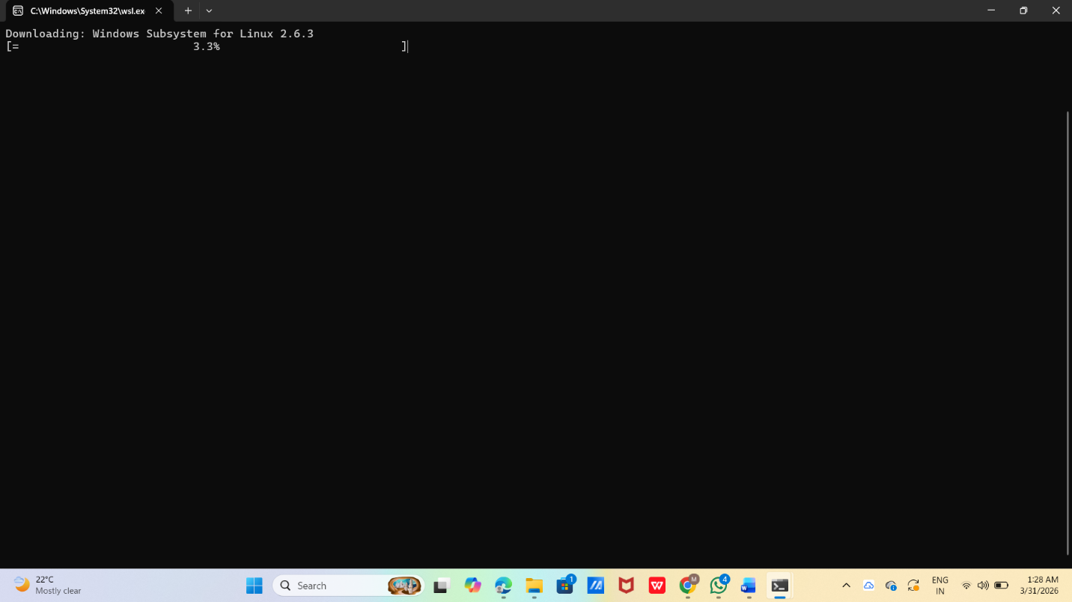

2.Run wsl –install command for install wsl and ubuntu linux
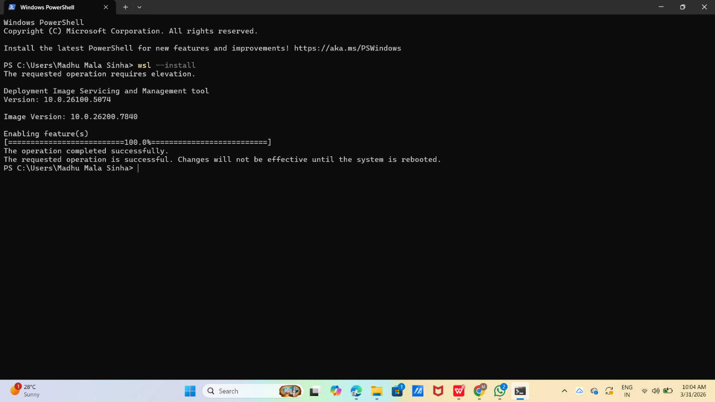

3.Run Script1
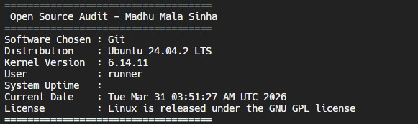

4.Run script 2
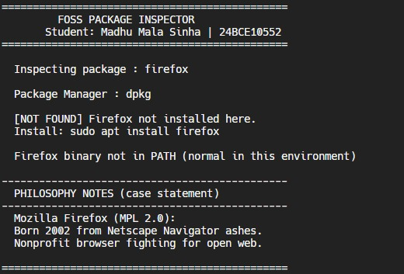

- Run script 3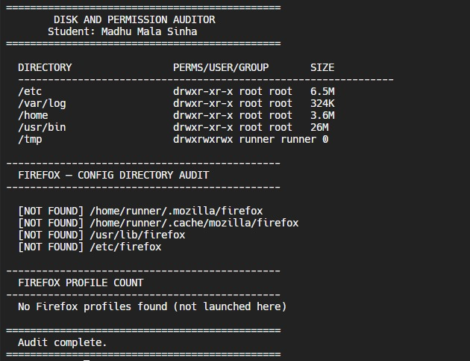

6.Run script 4
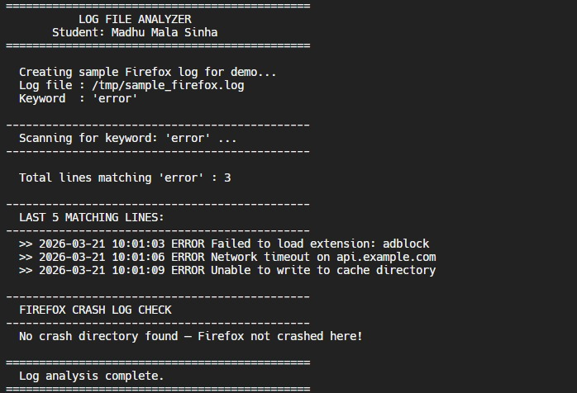

7.Run Script 5
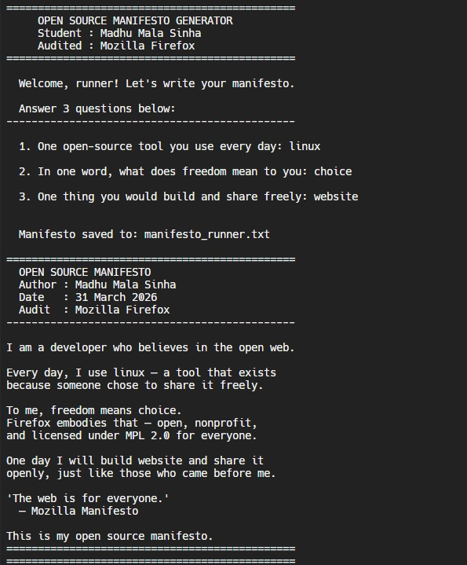

THANK YOU

